

Chandusoft Technologies Pvt Ltd, #10,Jeevan Bhima Nagar Main Road, LIC Colony

**SRS FOR SALES TEAM APPLICATION**

**Approver​: Mallikarjuna Chandu , MD@ Chandusoft**

**Project Head​: Gopi Keshavan**

**Project Members​:**

**Anusha J**

**Manasa G**

**Ronald Prajval**

**Shruti V S**

**Vidya Naik**

****Chandusoft Technologies Pvt Ltd

**INDEX**

**1. INTRODUCTION**

**1.1 Preambles**

**1.2 Flow Chart 2**

**1.2.1 Functional Description 3**

|  |  |
| --- | --- |
| Sales Team Application | 1 |

Chandusoft Technologies Pvt Ltd

**1.INTRODUCTION**

**1.1 Preambles:**

This application can be used by sales department of the companies. Here we are going to include some criteria to access by admin, who will have all the privileges like create BDM's, BDE's and Mapping. Admin authentication system should encourage strong passwords and email while maintaining data integrity and security. We propose that authentication schemes to allow admin to create email-id and password and send through their respective mail-id's to BDE and BDM.

In our system, we are using same login page to 3 actors where based on the database will differentiate who is Admin, BDM and BDE.

**1.2 FUNCTIONAL FLOW CHART:**

**Index/Login**

**Authentication**

**NO**

**YES**

**Authorization**

**Home Page**

Admin BDM BDE

|  |  |
| --- | --- |
| Sales Team Application | 2 |

1. Admin:

Logout

Home

Add BDM

Assign BDM to BDE

Add BDE

BDE List

BDM List

Update List

Update List

2. BDM:

Logout

Home

Client List

Profile

Mail

sent

Inbox

Send Proposal

|  |  |
| --- | --- |
| Sales Team Application | 3 |

3.BDE:

Logout

Home

Client List

Add Client

Profile

**1.2.1: Functional description:**

1. Admin - can create ,edit ,delete and view all the details of BDM and BDE.

2. BDM - can access BDE's and Client's.

3. BDE - create client records can update.

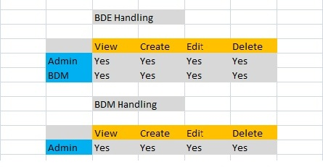

Fig: Represents Table of BDM and BDE

|  |  |
| --- | --- |
| Sales Team Application | 4 |